*Amazon Link*

*<*[*https://www.amazon.com/MakerFocus-Microcontroller-Compatible-Navigation-Positioning/dp/B075DD5746/ref=sr_1_1?ie=UTF8&qid=1538524302&sr=8-1&keywords=tinygpsplus*](https://www.amazon.com/MakerFocus-Microcontroller-Compatible-Navigation-Positioning/dp/B075DD5746/ref=sr_1_1?ie=UTF8&qid=1538524302&sr=8-1&keywords=tinygpsplus)*>*

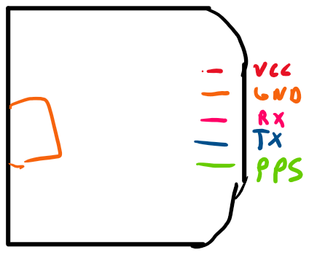

Libraries info- <<http://arduiniana.org/libraries/tinygps/>>

**Instance creation-**

#include "TinyGPS.h"

TinyGPS gps;

**Getting latitude and longitude**

gps.get_position(&lat, &lon); // lat and lon should be doubles

**Getting the speed**

Speed = gps.speed(); // returns speed within 100th of a knot.